Title
(The title of the article is no more than 15 words in English)
Author name¹; Author name²
¹Department, University, City, Country; ²Department, University, City, Country
E-mail for the corresponding author
Abstract (120-150 words):
Provide a self-contained and readable abstract (of up to 150 words) that briefly explains the salient aspects of the content, including, but not exclusively, the methods used to address the research question/hypothesis, a summary of the results, conclusions, applications or implications.
Key words (3-5 key words):…………………..

TiÊU ĐỀ
Tóm tắt (120-150 từ):……………..
Từ khóa (3-5 từ):………………….

1. Heading 1 [use this style for level one headings]
[Type your text here]

1.1 Heading 2 [use this style for level two headings]
[Type your text here]

1.1.1 Heading 3 [use this style for level three headings]
[Type your text here]
Heading level 4. [Use this style for level four headings]. Run the text on after a punctuation mark.
It is best if authors use three-level headings.
Block quote
If the quotation is over 40 words, you need to make it a block separate from the main text. In this case, use this style to display your quote.

Tables and figures
If you present your data in a table, follow this sample:
Table 1
Name of the Table
Items | Content 1 | Content 2
The caption comes above the table, started with Table 1 in bold, font size 11, the table title (no more than 15 words) is in italics, font size 11, and the content in the table is in font size 10.
If you present your data in a figure, the figure must be saved as a .jpg or .png file before being inserted to the main text. The caption comes below the figure, started with Figure/Chart 1 in bold, font size 11, with the figure/chart title (no more than 15 words) in italics, font size 11.
Figure 1
The Bloom's Taxonomy
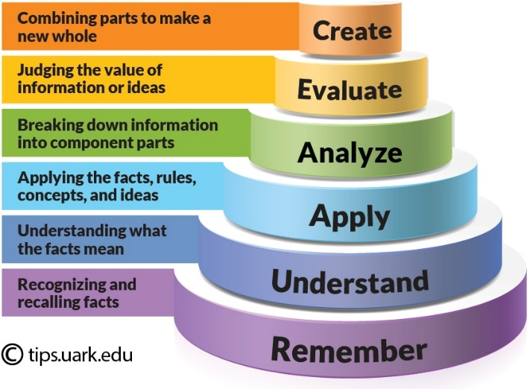
If the table or the figure is taken from a source, reference the author (after the caption) or acknowledge the source (by adding the information about it).
Please ensure that all tables are included in the main article document in an editable format (such as Word) rather than as images.

References
Manuscripts must conform to the American Psychological Association (APA) style guidelines, 7th Edition.

Authors may refer to the Author Guidelines available on the website of the Journal of Inquiry into Languages and Cultures, University of Foreign Languages and International Studies, Hue University: https://jilc.vn

The article is encouraged to comply with the common structure of the scientific article, called IMRaD. After title and abstract, the article includes Introduction (research question, significance, review of background), Methods (data collection and analysis), Results and Discussion and conclusions. The article should also consist of references and appendices (if relevant).

